Milestone 2

Ryan Coon

CST-150

Professor Mark Smithers

July 31, 2022

GitHub Link to source code:

https://github.com/rcoon1/CST-150/tree/main/Milestones/Milestone%202

Loom Video walkthrough of running program:

https://www.loom.com/share/3f02672d82c74660a60f8b67d85e6739

This program is written in the C# language utilizing windows forms. The goal of this program is to enter and track inventory along with storage locations, vendors and a sales price. I will also implement a selling system that will generate a pdf invoice. The goal for milestone 2 is to create the inventory class along with objects utilizing the class. This is a work in progress and it will change as I add the database connections. I utilized many forms to change the look and to less confuse the user instead of putting it all on one form. This has been challenging for me but I like how it is turning out so far.

Screenshots:

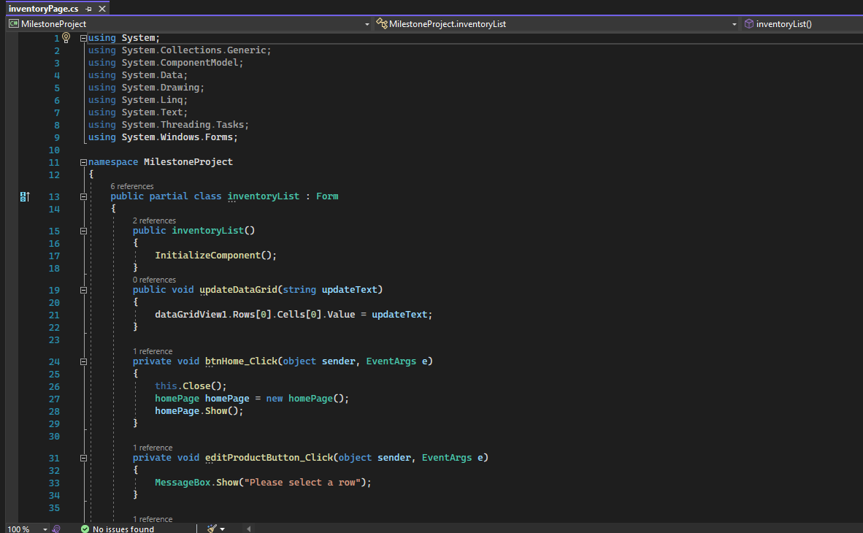

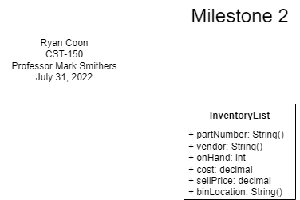

This is the UML just for the inventory class. As I implement the other classes this UML will grow exponentially.